**Record of Technical Anomaly**

**Technical Anomaly No: TA421**

**PART 1: Issue, impact assessment and signing open**

**Raised by: Hannah Ford** **Date: 21/01/22**

**OP / Method: OP224**

**Analytical sequence(s) affected** *(where appropriate)***: EC0790**

**Details** *(please tick relevant box(es) and provide supplementary information where required)***:**

R QC point(s) above/below ±2SD □ Bracketing standard(s) outside limits

□ QC point(s) above/below ±3SD □ QC Recovery outside limits

R QC point(s) outside expanded uncertainty R Other *(add details below)*

Both residual (@55.5%) and signal to noise (@5.2) failed for 2.5ppb calibration level. The baseline was noisy, which is reflected in the signal to noise failure, and may have contributed to a difficulty in integrating the small peak accurately. 2.5ppb level was excluded from the calibration curve and the reporting limit adjusted to 5ppb (residual 16.3%, s/n 18.9).

**Figure 1. Chromatography of Cal 2.5 standard**

An interfering peak with area >400 was also present in the Cal 0 standard (area 539) but it was not thought to be large enough to have significantly impacted and contributed to the failures in the Cal 2.5 standard. Refer to TA419 – a review is ongoing to decide if peak area is the most appropriate measure of interference. A suspected leak was investigated between runs EC0789 and EC0790 and the seal between the column and push fit liner found to be loose. Remedying this has succeeded in reducing the area of the interfering peak, although still not to the level acceptable according to the OP, but a high MS response must also be taken into account.

**Figure 2. Interfering peak in Cal 0 standard**

2 (non-consecutive) out of 4 QCA points were also above the expanded uncertainty limit, and one of these was also above the 2SD warning limit. This was due to a poorly resolved interfering peak. All bracketing standards and QCB results were well within limits, showing the issue was sample specific and not instrumental. There were multiple samples with the same interfering peak; these samples will all not be reported but repeated at a higher dilution so as to better resolve the target peak.

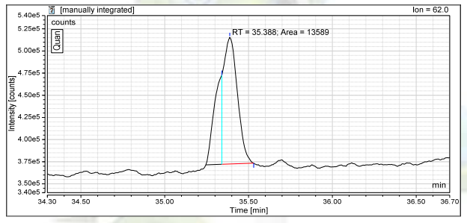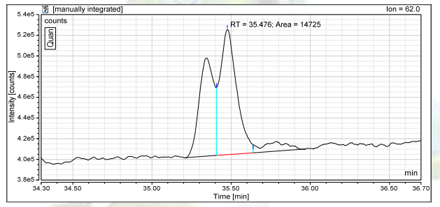

**Figure 3. Chromatography of 2 QCA injections with results >EU**

□ No apparent reason for this anomaly

**Recommended Action:**

□ No action required out with the usual close monitoring of the Quality Control data in subsequent runs.

A front end clean will be performed to remedy the baseline noise issues. All samples with interferences will be repeated at a higher dilution.

**Explanation why the issue does not impact data quality & why it isn’t a departure:**

Reporting limit is adjusted to reflect the issues with the 2.5ppb cal standard. All QCA points are within the 3SD action limit, and all samples affected by the same issue will not be reported from this run.

**Management Review:**

***I agree to open this Technical Anomaly and confirm that this would not prevent results from being reported.***

**Authorised by:**

**(Technical/Services/Quality Manager)**

**Date:**

**PART 2: Follow-up actions and close-out**

**Follow-up actions conducted:**

□ No follow up required

**Signed off & closed by Quality Manager:**

**Date: ____________**

